Session 11

- Create a Python list to represent a playlist of 5 song durations in seconds (e.g., [210, 180, 245, 200, 175]). Print the total duration of the playlist.
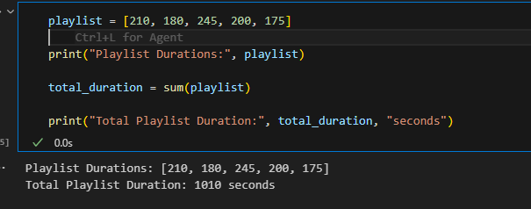

- Represent a 3x3 matrix in Python to store the ratings (1-5) given by 3 friends to 3 different food items on Swiggy. Print the matrix and display the rating each friend gave to the second food item.
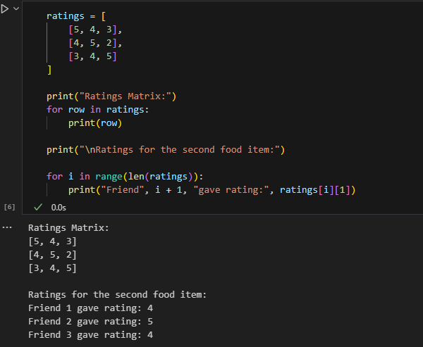
- Given a matrix representing the number of orders for 4 different dishes across 3 days (rows: days, columns: dishes), write code to calculate and print the total orders for each dish.
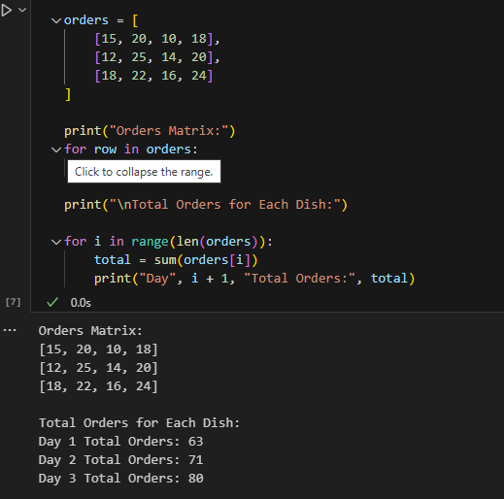

- Imagine you have a table of 5 Flipkart products with columns for price and quantity sold. Represent this data as a matrix in Python, then write a function to calculate the total revenue for each product.<br><br><em><strong>Hint:</strong> Multiply price and quantity for each row, then print the results.</em>
